Nicky Southall Outdoor Flatwork Clinic
Friday 27th May 2022
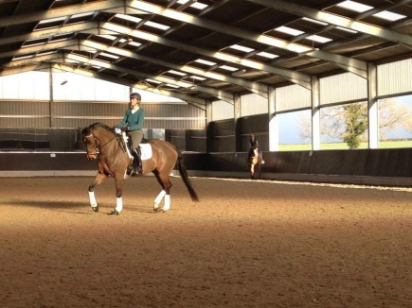
10.00-10.45am
Suzi Reed & Caroline Doolittle
11.00-11.45am
Nikki Peacock & Sallyann Gresham
11.45am-12.30pm
Colin Bradley & Tracey Blackwell
12.45pm – 1.30pm
Leah Tolley & Cath Lawton
1.30pm – 2.15pm
Ruby Phillips & **SPACE**

