Nicky Southall Outdoor Flatwork Clinic
Friday 28th January 2022
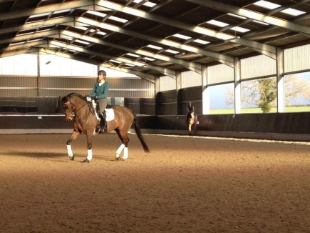
9.30am-10.15pm
N Peacock & J Pudge
10.15-11.00pm
W Yates & D Claridge
11.15pm-12.00pm
C Bradley & G Beaumont
12.45pm-1.30pm
S Burns & B Donnelly
1.45pm – 2.30pm
R Phillips & R Vale
2.30pm – 3.15pm
A Langford & L Turford

