Nicky Southall Flatwork Clinic
Friday 13th December 2019
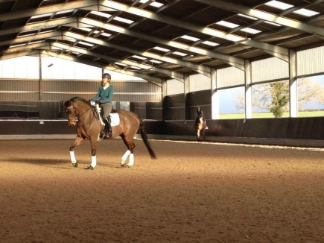

11.00am-11.45pm R Phillips
N Peacock

11.45am-12.30pm E Snade
A Harris

12.45pm-1.30pm C Keen
J Nicholas

1.30-2.15pm L Renshaw

