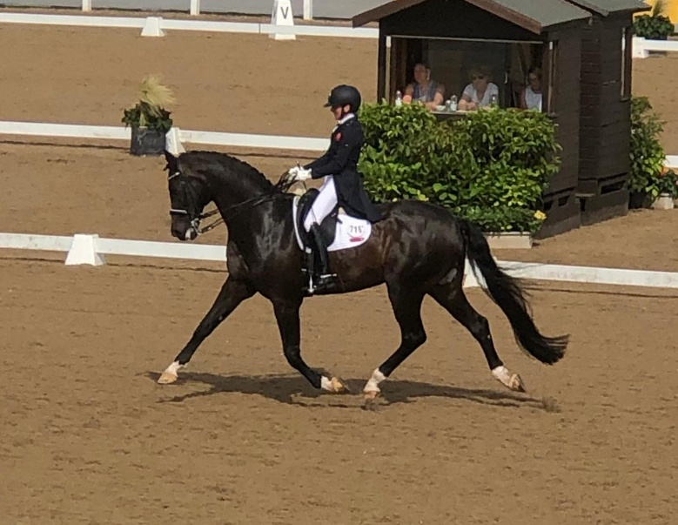

Isobel Wessel’s Clinic
At
Stourport Riding Centre

9.00am G Ash.
9.45am C Savage.
10.30am M Walters
11.15pm N Pierce
12.15pm C Sandrock
1.00pm A Kolleth
1.45pm K Perry.
2.30pm N Southall
3.15pm S Holloway

