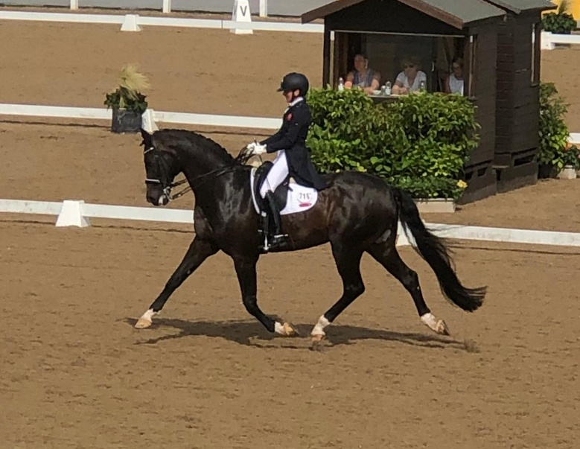

Isobel Wessel’s Clinic
At
Stourport Riding Centre

9.00am G Ash.
9.45am C Savage.
10.30am M Walters
11.15pm N Lawson
12.15pm E Perry
1.00pm K Jones
1.45pm A Higgins
2.30pm L Denning
3.15pm L Cartwright

