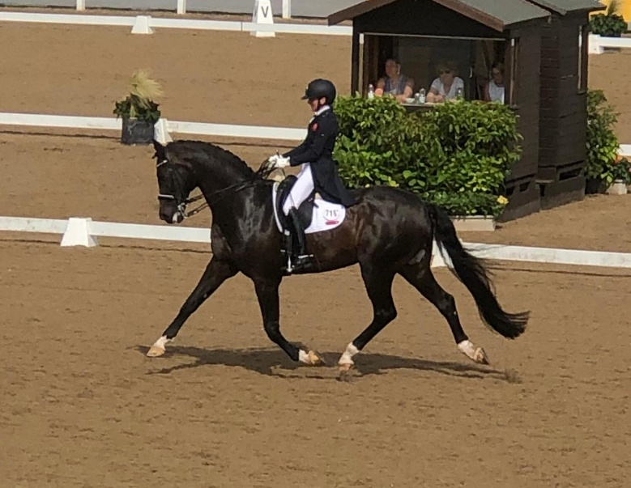

Isobel Wessel’s Clinic
At
Stourport Riding Centre

10.00am G Ash

10.45am C Savage

11.30am A Kolleth

12.15pm N Pierce

1.15pm A Higgins

2.00pm A Trigg

2.45pm S Holloway

