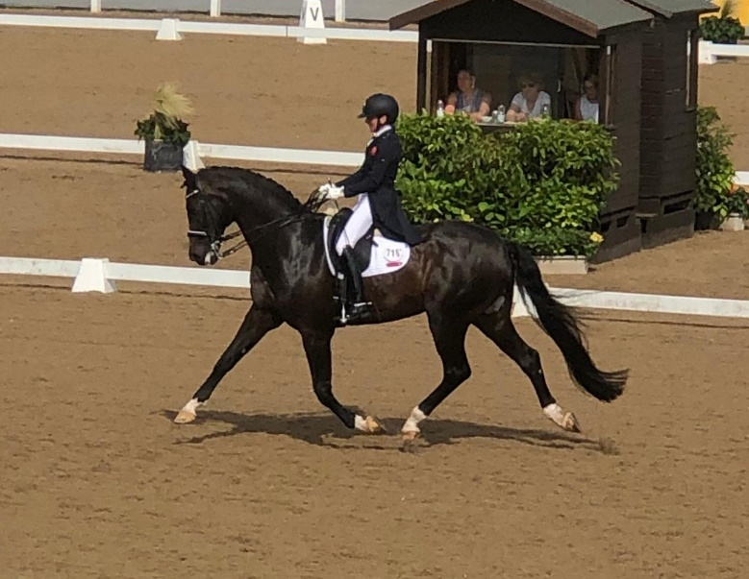

Isobel Wessel’s Clinic
At
Stourport Riding Centre

9.00am G Ash.
9.45am C Savage.
10.30am M Walters
11.15pm N Lawson
12.15pm N Hill
1.00pm E Perry
1.45pm D Bremner

