Alec Trickett Clinic
Thursday 20th January
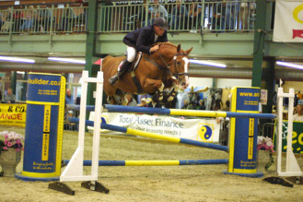
12.30pm – Z Smith
1.00pm – R Phillips
1.30pm – S Stokes
2.00pm – C Lawton
2.30pm – J Gallagher
3.00pm – P Walker
3.30pm – S Brett
4.00pm – H Tett
4.30pm – N Peacock
5.00pm – J Tesh

