Nicky Southall Outdoor Flatwork Clinic
Friday 30th July 2022
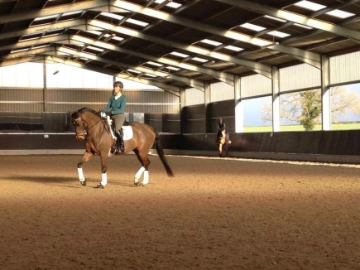
10.00-10.45am
Shona Cutler & Caroline Mockford
10.45-11.30am
Griselda Beaumont & Rhian Gould
11.45am-12.30pm
Jane Williams & Liz Mansfield
12.30pm-1.15pm
Lucy Hawker & Lauren Barton

