Nicky Southall Outdoor Flatwork Clinic
Friday 21st October 2022
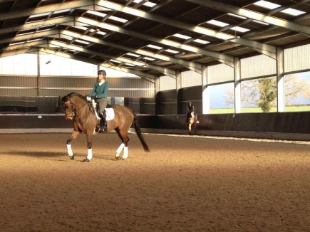
10.00-10.45am
Shona Cutler & Caroline Doolittle
11.00-11.45am
Zarana Haines & Rhian Gould
11.45am-12.30pm
Liz Mansfield & Jane Venebales

