Nicky Southall Outdoor Flatwork Clinic
Friday 25th November 2022
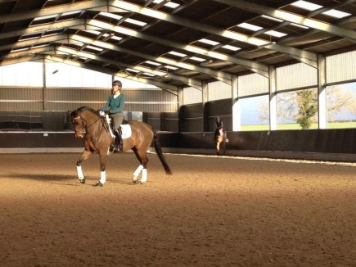
10.00-10.45am
Nikki Peacock & Jane Williams
10.45-11.30am
Shona Cutler & Caroline Mockford
11.45am-12.30pm
Griselda Beaumont & Katie Rose
12.30pm -1.15pm
Kirsty Kirk & Diane Boros
1.30pm-2.15pm
Martine Lee & Jackie Lee
2.15pm-3.00pm
Lorna Cavalier-White & ***SPACE***

