Nicky Southall Outdoor Flatwork Clinic
Friday 03rd May 2024
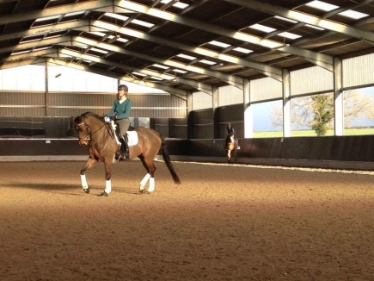
10.00-10.45am
Nikki Peacock & ***SPACE***
10.45-11.30am
Lyndsey Denning & Lucy Hawker

