Nicky Southall Flatowrk Clinic
Friday 8th March 2019
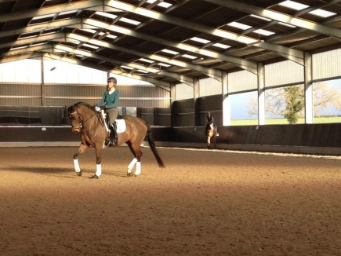
11.00-11.45 Nikki Peacock
Claire Cartwright

11.45am-12.30pm Jenny Atherley
Haley Smith

12.30-1.15pm Sallyann Burns

1.30pm-2.15pm Ruby Phillips
Aleisha Harris

