Nicky Southall Outdoor Flatwork Clinic
Friday 25TH March 2022
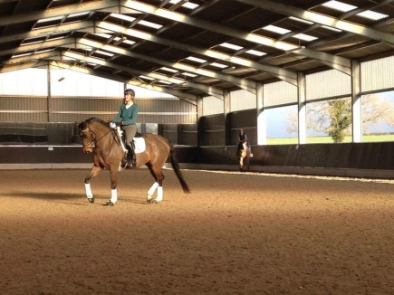
10.10-10.45am
Shona Cutler & Caroline Dootlittle
10.45-11.30am
Nikki Peacock & Alice Whiteman
11.45am-12.30pm
Jenny Pudge & Andrea Baker
12.45pm – 1.30pm
R Phillips & T Blackwell
1.30pm – 2.15pm
Leah Tolley & Lauren Barton

