Nicky Southall Outdoor Flatwork Clinic
Friday 17th June 2022
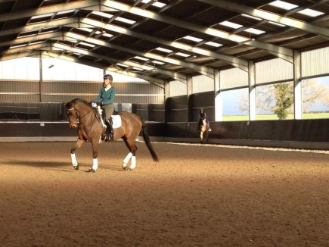
11.00-11.45am
Nikki Peacock & Ruby Phillips
11.45am-12.30pm
Bessie Donnelly & Jade Clark
12.45pm – 1.30pm
Tracey Breakwell & Cath Lawton
1.30pm – 2.15pm
Amanda Jayne Cullen & Laura Turford

