Nicky Southall Outdoor Flatwork Clinic
Friday 22nd July 2022
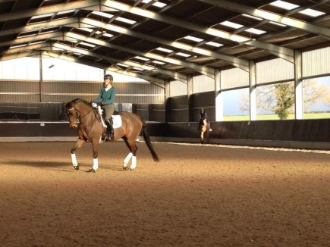
10.00-10.45am
Nikki Peacock & Griselda Beaumont
11.00-11.45am
Joann Nicholas & Jane Williams
11.45am-12.30pm
Sarah Turner & Harriet Fox-Davies

