Nicky Southall Flatowrk Clinic
Friday 18th January 2019
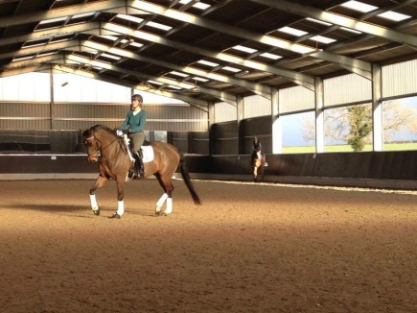
11.00-11.45 Ruby Phillips
Claire Cartwright

11.45am-12.30pm Sallyann Burns
***SPACE***

12.30-1.15pm Lorna Strutt
Chyna Savage

1.30pm-2.15pm Chyna Savage
Aleisha Harris

