Nicky Southall Outdoor Flatwork Clinic
Thursday 17th February 2022
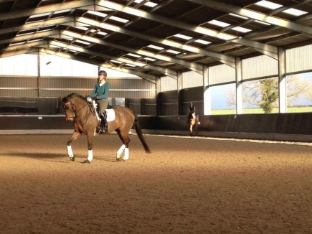
10.00am-10.45pm
Caroline Doolittle & Shona Cutler
10.45-11.30pm
Nikki Peacock & Ruby Phillips
11.45pm-12.30pm
Bessie Donnelly & Tracey Balckwell
12.30pm-1.15pm
Helen Walker & Abbie Harvey
1.30pm – 2.15pm
Griselda Beaumont & Laura Turford
2.30pm-3.15pm
Leah Tolley & Lauren Barton

