Nicky Southall Outdoor Flatwork Clinic
Friday 22nd April 2022
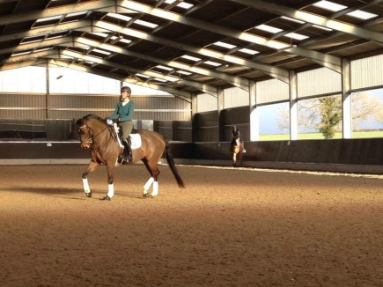
10.00-10.45am
**SPACE** & Caroline Doolittle
11.00-11.45am
Nikki Peacock & Oliver Gould
11.45am-12.30pm
Amanda Cullen & Tracey Blackwell
12.45pm – 1.30pm
Griselda Beaumont & **SPACE**
1.30pm – 2.15pm
Ruby Phillips & Lauren Barton

