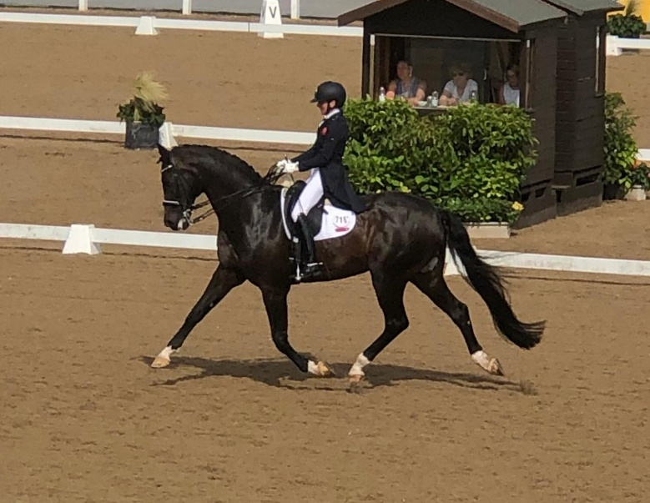

Isobel Wessel’s Clinic
At
Stourport Riding Centre

10.00am G Ash

10.45am C Savage

11.30am E Perry

12.15pm R Hall

1.15pm E Perry

2.00pm A Trigg

2.45pm J Cotterill

3.30pm – A Higgins

