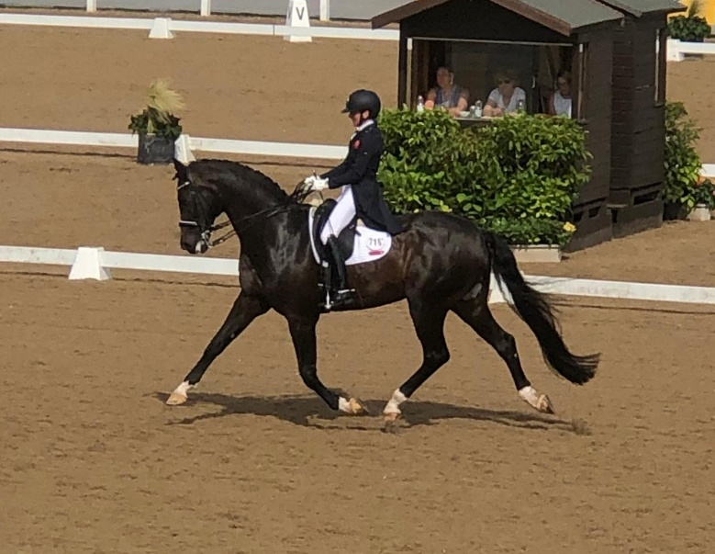

Isobel Wessel’s Clinic
At
Stourport Riding Centre

9.00am G Ash.
9.45am C Savage.
10.30am C Gaskin
11.15pm E Perry

