Alec Trickett Clinic
Friday 26th April 2024
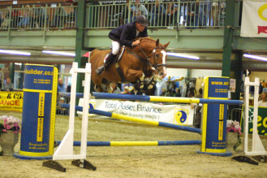
1.30pm – C Lawton
2.00pm – C Lawton
2.30pm – M Mitchell
3.00pm – T Gillard
3.30pm – S Brett
4.00pm – S Stokes
4.30pm – H Blake
5.00pm – E Hall
5.30pm – N Peacock
6.00pm – C FLint

