Alec Trickett Clinic
Tuesday 18th June 2019
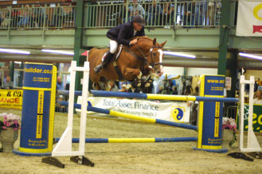
1.30pm C Savage
2.00pm C Savage
2.30pm C Savage
3.00pm L Hawkeswood
3.30pm – R Phillips
4.00pm M Ballard
4.30pm S Watkins
5.00pm N Peacock
5.30pm A Harris
6.00 P Young
6.30 K Blumberg
7.00 L Blumberg

