Alec Trickett Clinic
Tuesday 7th June 2022
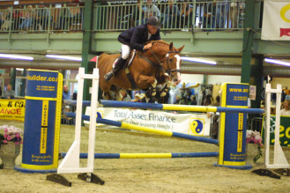
12.30pm-L Turford
1.00pm -T Ladds
1.30pm – S Turner
2.00pm – S Brett
2.30pm – P Walker
3.00pm – H Fox-Davies
3.30pm – E Sargent
4.00pm – S Parkes
4.30pm – N Peacock
5.00pm – R Hall
5.30pm – H Tett
6.00pm – R Phillips
6.30pm – T Mayo

