Alec Trickett Clinic
Tuesday 07th May 2019
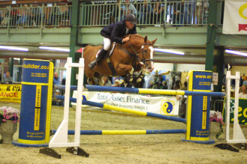
1.00pm C Savage
1.30pm R Phillips
2.00pm C Savage
2.30pm C Savage
3.00pm L Anderson
3.30pm – V Hill
4.00pm E Field
4.30pm S Watkins
5.00pm N Peacock
5.30pm A Harris
6.00 K Carrington

